CURRICULUM VITAE
- Personal data
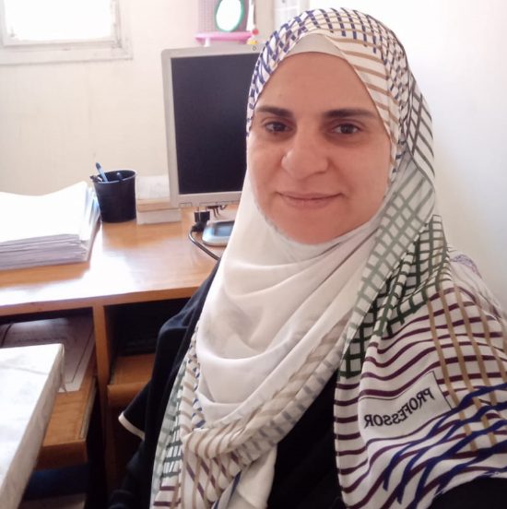
Name: Rasha Sobhy Abd-Elmoamen Abd-Elghani
Date of Birth: December 6, 1983.
Place of Birth: Qaluib– Egypt
Nationality: Egyptian
Marital Status: Married
Home Phone: +201155816589
Mobile: +201094693655
Work Phone: +20133225494
Address: Benha University– Faculty of Science – Physics Department, Egypt – Qalubia – Benha – 13518.
E-mail: rasha.abdelghani@fsc.bu.edu.eg ; hamzafares1520@gmail.com;
- Degrees
2021: Ph.D. in Electronics from Faculty of Science, Physics Department, Benha University. Thesis Topic : “Organic – Inorganic Hybrids for Semiconductor Devices: Fabrication and Characterization”.
2012: M.Sc. in Electronics physics from Faculty of Science, Physics Department, Ain Shams University. Thesis Topic: “Design and simulation of the characteristics of Microcontrolled RF antennas”.
2007: Pre-Master in Experimental Physics from Faculty of Science, Physics Department, Benha University.
2005: B.Sc. From Faculty of Science, Physics Department, Benha University.
- Professional History
2022- Present: Lecturer in Faculty of Science, Physics Department, Benha University.
2012 – 2021: Assistant Lecturer in Faculty of Science, Physics Department, Benha University.
2006 – 2011: Demonstrator in Faculty of Science, Physics Department, Benha University.
- Computer Skills:
• Microsoft Office package (word. Access, excel, PowerPoint, internet, information technology, using the computer and managing files).
• Programming with Matlab, ORCAD, Proteus, and origin.
- Languages Native language:- Arabic , Second Language:- English Very Good

- Teaching Activity
Undergraduate Courses
Experimental physics (lab. of Heat and properties of matter)
Experimental physics (lab. of electricity and magnetism)
Experimental physics (lab. of optics)
Experimental physics lab of (solid state, electronics, Modern physics and nuclear)
Courses of electricity, alternating current, electromagnetism, Heat, Optics, semiconductor devices, electronic devices, solid state, bioelectronics, logic circuits, and electrical circuits.
Graduate courses
- Nano devices and nanoionics
- Electronic devices

- Research Interests
- Material science
- Solid state physics
- Electronics devices
- Resistive switching memory
- Polymer physics
- Nanotechnology
- Nano electronics – Nano devices – bioelevtronics.

- Home Page online:
https://scholar.google.com/citations?hl=en&user=j-CnxhQAAAAJ.
https://orcid.org/my-orcid?orcid=0000-0001-8993-6830.
linkedin.com/in/rasha-sobhy-34b74430a

- Attended workshops and Conferences:
2nd scientific Conference of Faculty of science, Benha university, applied physics and sustainable development on 27th-28th September 2020.

- The published papers
- Abd-Elghany, R. S., Khoder, H., Khalil, R., & El-Mansy, M. K. (2021). Study on nonlinear conduction of PEDOT: PSS conducting polymer. Benha Journal of Applied Sciences, 6(2), 47-56.
- Khalil, R., El-Desouky, H., Sobhy, R., & El-Mansy, M. K. (2023). Electrical characterization of AgNPs-PVA nanocomposites thin film-based heterojunction diode. Physica Scripta, 98(4), 045805.
- Sobhy, R., & Khalil, R. (2023). Carrier transport and Negative differential resistance of electrically bipolar devices based on poly (3, 4-ethylene-dioxythiophene): Poly (styrene sulfonate) film. Microelectronics Journal, 140, 105922.
- Sobhy, R., El-Mansy, M., & Khalil, R. (2024). An Electrically Resistive Switching Nonvolatile Memory System Based on PEDOT: PSS. physica status solidi (a), 221(4), 2300363.

